**SALESFORCE PROJECT**

**MILKEASE**

* **Phase 9:  Reporting, Dashboards & Security Review.**

👉 Goal **:  Monitor business & secure data.**

* **Reports** :-
* **Milk Delivery Utilization Report** (How many litres delivered per month).

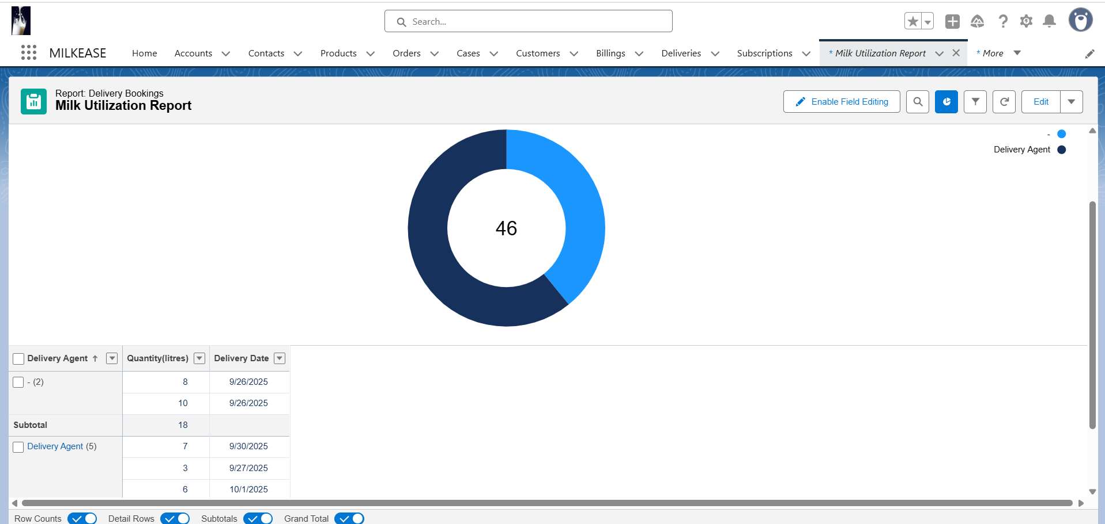

* **Dashboard**:-
* **Manager’s Revenue** (Show total revenue and deliveries for dairy manager).

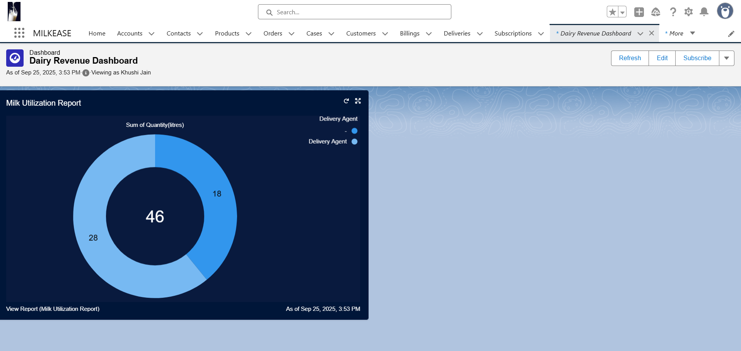

* **Sharing Settings**:-
* **Bookings Private, Milk Products Public** (Protect customer booking info but keep product list open).

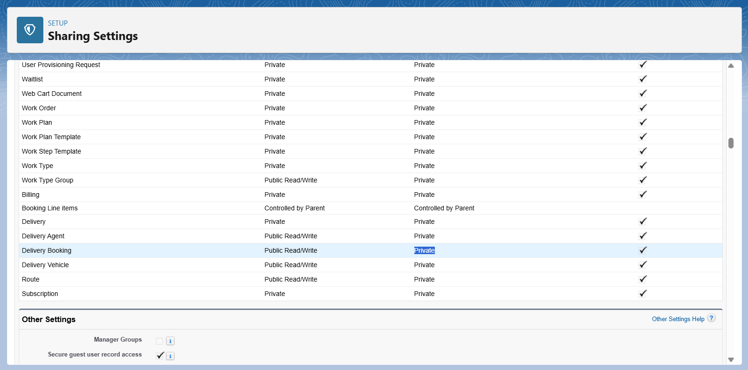

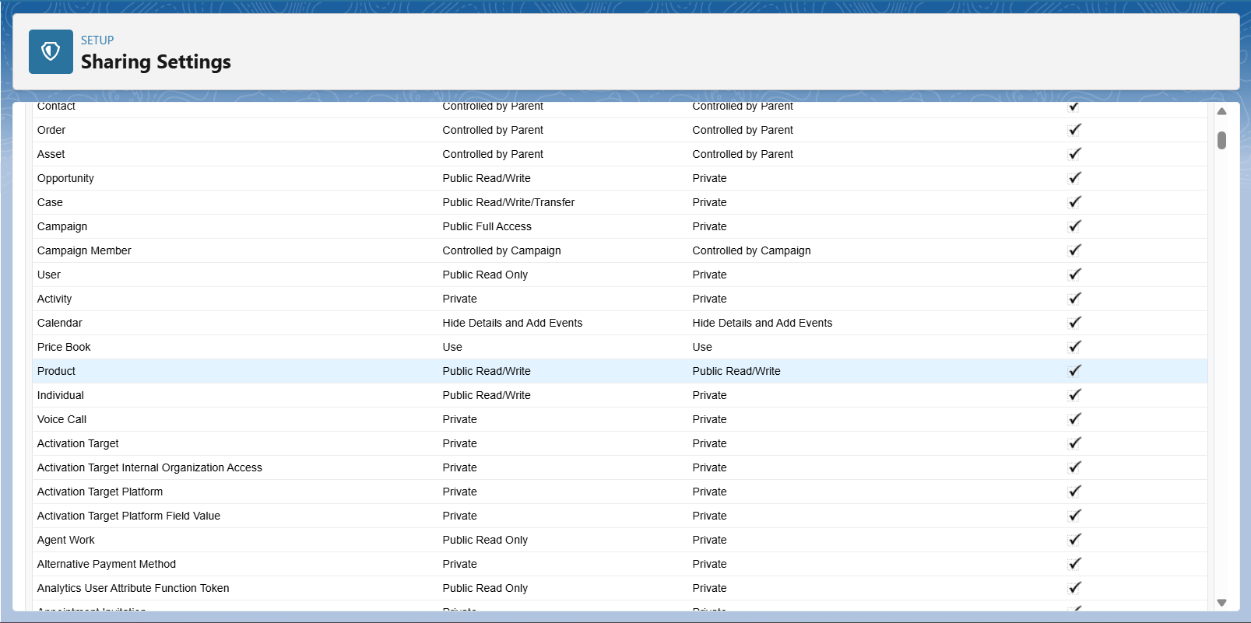

* **Add Rules**:-
* Managers → access to all Bookings.
* Agents → access only to their own Bookings.

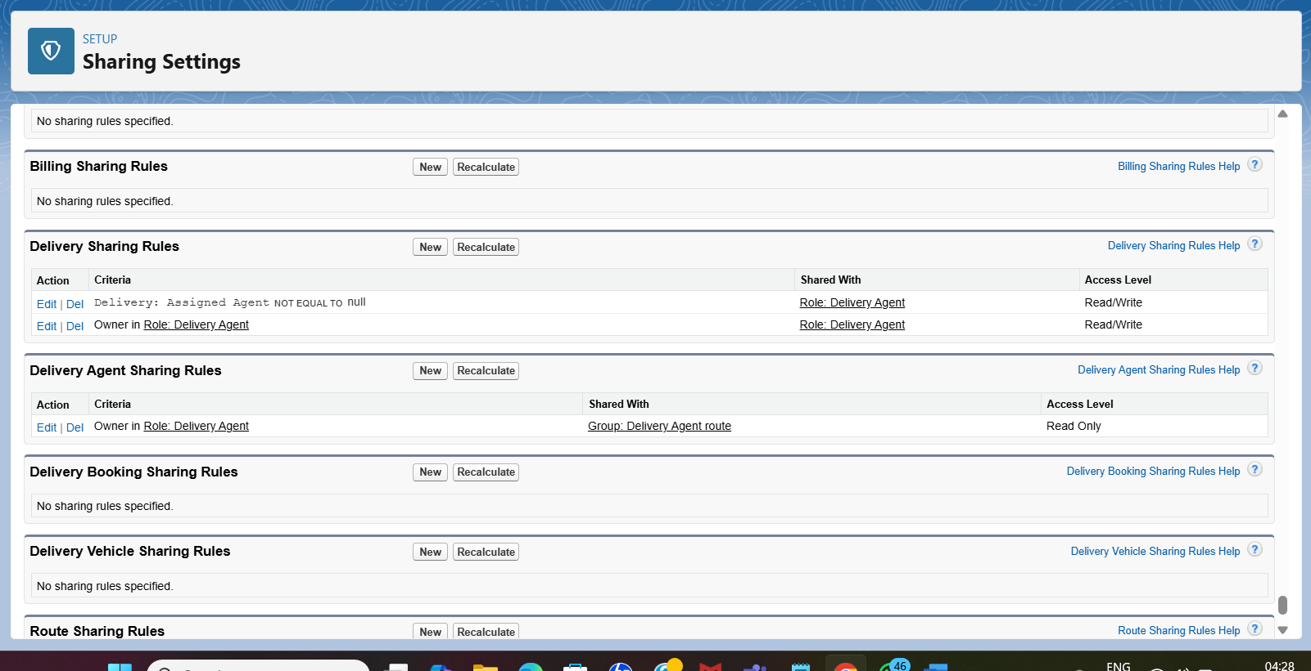

* **Field Level Security :**-
* **Hide “Customer ID Proof” from Delivery Agents** (Protect customer-sensitive information).

